#15861 Analysis

After Patch Apply

1. With Timestamp(0)

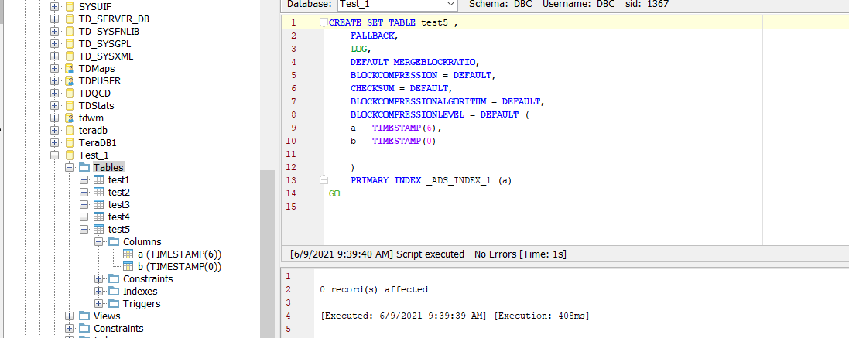

2. With Timestamp only

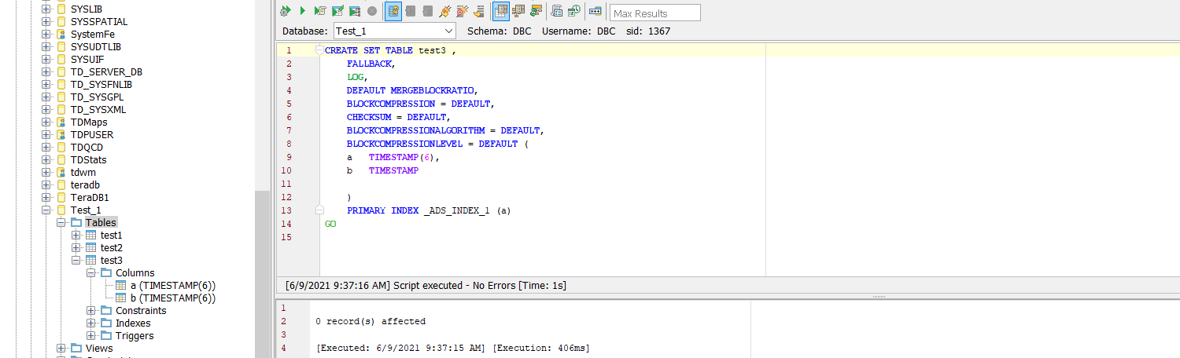

Without Patch Apply

1. With Timestamp(0)

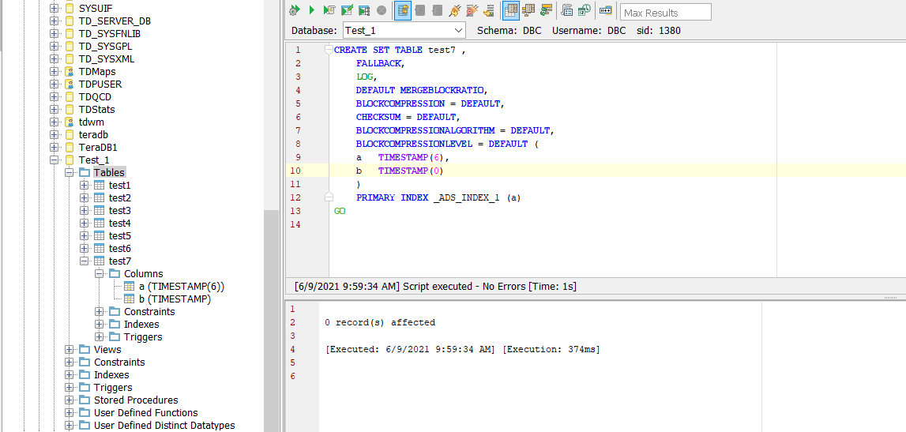

2. With Timestamp

