Create Database SQLServer 2016 SP3

go

SET ANSI_NULLS ON
GO
SET QUOTED_IDENTIFIER ON
GO
IF NOT EXISTS (SELECT * FROM sys.objects WHERE object_id = OBJECT_ID(N'[dbo].[TypeExport]') AND type in (N'U'))
BEGIN
CREATE TABLE [dbo].[TypeExport](
[Id] [int] IDENTITY(1,1) NOT FOR REPLICATION NOT NULL,
[Omschrijving] [varchar](50) NOT NULL,
[Insertname] [varchar](50) NOT NULL,
[Insertdate] [datetime] NOT NULL,
[Updatename] [varchar](50) NOT NULL,
[Updatedate] [datetime] NOT NULL,
[Concurrencyvalue] [smallint] NOT NULL,
[Aktief] [bit] NOT NULL,
CONSTRAINT [PK_TypeExport] PRIMARY KEY CLUSTERED
(
[Id] ASC
)WITH (PAD_INDEX = OFF, STATISTICS_NORECOMPUTE = OFF, IGNORE_DUP_KEY = OFF, ALLOW_ROW_LOCKS = ON, ALLOW_PAGE_LOCKS = ON, FILLFACTOR = 100) ON [PRIMARY]
) ON [PRIMARY]
END
GO
IF NOT EXISTS (SELECT * FROM sys.objects WHERE object_id = OBJECT_ID(N'[dbo].[DF_TypeExport_Insertname]') AND type = 'D')
BEGIN
ALTER TABLE [dbo].[TypeExport] ADD CONSTRAINT [DF_TypeExport_Insertname] DEFAULT (user_name()) FOR [Insertname]
END
GO
IF NOT EXISTS (SELECT * FROM sys.objects WHERE object_id = OBJECT_ID(N'[dbo].[DF_TypeExport_Insertdate]') AND type = 'D')
BEGIN
ALTER TABLE [dbo].[TypeExport] ADD CONSTRAINT [DF_TypeExport_Insertdate] DEFAULT (getdate()) FOR [Insertdate]
END
GO
IF NOT EXISTS (SELECT * FROM sys.objects WHERE object_id = OBJECT_ID(N'[dbo].[DF_TypeExport_Updatename]') AND type = 'D')
BEGIN
ALTER TABLE [dbo].[TypeExport] ADD CONSTRAINT [DF_TypeExport_Updatename] DEFAULT (user_name()) FOR [Updatename]
END
GO
IF NOT EXISTS (SELECT * FROM sys.objects WHERE object_id = OBJECT_ID(N'[dbo].[DF_TypeExport_Updatedate]') AND type = 'D')
BEGIN
ALTER TABLE [dbo].[TypeExport] ADD CONSTRAINT [DF_TypeExport_Updatedate] DEFAULT (getdate()) FOR [Updatedate]
END
GO
IF NOT EXISTS (SELECT * FROM sys.objects WHERE object_id = OBJECT_ID(N'[dbo].[DF_TypeExport_ConcurrencyValue]') AND type = 'D')
BEGIN
ALTER TABLE [dbo].[TypeExport] ADD CONSTRAINT [DF_TypeExport_ConcurrencyValue] DEFAULT ((0)) FOR [Concurrencyvalue]
END
GO
IF NOT EXISTS (SELECT * FROM sys.objects WHERE object_id = OBJECT_ID(N'[dbo].[DF_TypeExport_Aktief]') AND type = 'D')
BEGIN
ALTER TABLE [dbo].[TypeExport] ADD CONSTRAINT [DF_TypeExport_Aktief] DEFAULT ((1)) FOR [Aktief]
END
GO

SET ANSI_NULLS ON
GO
SET QUOTED_IDENTIFIER ON
GO
IF NOT EXISTS (SELECT * FROM sys.objects WHERE object_id = OBJECT_ID(N'[dbo].[AanslagGroep]') AND type in (N'U'))
BEGIN
CREATE TABLE [dbo].[AanslagGroep](
[Id] [int] IDENTITY(1,1) NOT FOR REPLICATION NOT NULL,
[GroepId] [int] NOT NULL,
[SoortaanslagId] [int] NOT NULL,
[Omschrijving] [varchar](50) NOT NULL,
[InsertName] [varchar](50) NOT NULL,
[InsertDate] [datetime] NOT NULL,
[UpdateName] [varchar](50) NOT NULL,
[UpdateDate] [datetime] NOT NULL,
[ConcurrencyValue] [smallint] NOT NULL,
CONSTRAINT [PK_AanslagGroep] PRIMARY KEY CLUSTERED
(
[Id] ASC
)WITH (PAD_INDEX = OFF, STATISTICS_NORECOMPUTE = OFF, IGNORE_DUP_KEY = OFF, ALLOW_ROW_LOCKS = ON, ALLOW_PAGE_LOCKS = ON, FILLFACTOR = 100) ON [PRIMARY]
) ON [PRIMARY]
END
GO
SET ANSI_NULLS ON
GO
SET QUOTED_IDENTIFIER ON
GO
IF NOT EXISTS (SELECT * FROM sys.objects WHERE object_id = OBJECT_ID(N'[dbo].[AanslagOpslag]') AND type in (N'U'))
BEGIN
CREATE TABLE [dbo].[AanslagOpslag](
[Id] [int] IDENTITY(1,1) NOT FOR REPLICATION NOT NULL,
[VanDatum] [date] NOT NULL,
[OudeAanslagSoortId] [int] NOT NULL,
[JarenRange1] [int] NOT NULL,
[JarenRange2] [int] NOT NULL,
[JarenRange3] [int] NOT NULL,
[JarenRange4] [int] NOT NULL,
[OpslagPercentage1] [int] NOT NULL,
[OpslagPercentage2] [int] NOT NULL,
[OpslagPercentage3] [int] NOT NULL,
[OpslagPercentage4] [int] NOT NULL,
[NieuweAanslagSoortId] [int] NOT NULL,
[Insertname] [varchar](50) NOT NULL,
[Insertdate] [datetime] NOT NULL,
[Updatename] [varchar](50) NOT NULL,
[Updatedate] [datetime] NOT NULL,
[Concurrencyvalue] [smallint] NOT NULL,
CONSTRAINT [PK_AanslagOpslag] PRIMARY KEY CLUSTERED
(
[Id] ASC
)WITH (PAD_INDEX = OFF, STATISTICS_NORECOMPUTE = OFF, IGNORE_DUP_KEY = OFF, ALLOW_ROW_LOCKS = ON, ALLOW_PAGE_LOCKS = ON, FILLFACTOR = 100) ON [PRIMARY]
) ON [PRIMARY]
END
GO
SET ANSI_NULLS ON
GO
SET QUOTED_IDENTIFIER ON
GO
IF NOT EXISTS (SELECT * FROM sys.objects WHERE object_id = OBJECT_ID(N'[dbo].[AanslagSoort]') AND type in (N'U'))
BEGIN
CREATE TABLE [dbo].[AanslagSoort](
[Id] [int] IDENTITY(1,1) NOT FOR REPLICATION NOT NULL,
[Omschrijving] [varchar](50) NOT NULL,
[InsertName] [varchar](50) NOT NULL,
[InsertDate] [datetime] NOT NULL,
[UpdateName] [varchar](50) NOT NULL,
[UpdateDate] [datetime] NOT NULL,
[ConcurrencyValue] [smallint] NOT NULL,
[OmschrijvingReport] [varchar](50) NULL,
[Voorlopig] [bit] NOT NULL,
[Individueel] [bit] NOT NULL,
[TypeExportId] [int] NULL,
[Aktief] [bit] NOT NULL,
CONSTRAINT [PK_AanslagSoort] PRIMARY KEY CLUSTERED
(
[Id] ASC
)WITH (PAD_INDEX = OFF, STATISTICS_NORECOMPUTE = OFF, IGNORE_DUP_KEY = OFF, ALLOW_ROW_LOCKS = ON, ALLOW_PAGE_LOCKS = ON, FILLFACTOR = 100) ON [PRIMARY]
) ON [PRIMARY]
END
GO
IF NOT EXISTS (SELECT * FROM sys.indexes WHERE object_id = OBJECT_ID(N'[dbo].[AanslagGroep]') AND name = N'IX_AanslagGroep_SoortaanslagId')
CREATE NONCLUSTERED INDEX [IX_AanslagGroep_SoortaanslagId] ON [dbo].[AanslagGroep]
(
[SoortaanslagId] ASC
)WITH (PAD_INDEX = OFF, STATISTICS_NORECOMPUTE = OFF, SORT_IN_TEMPDB = OFF, DROP_EXISTING = OFF, ONLINE = OFF, ALLOW_ROW_LOCKS = ON, ALLOW_PAGE_LOCKS = ON, FILLFACTOR = 100) ON [PRIMARY]
GO
IF NOT EXISTS (SELECT * FROM sys.indexes WHERE object_id = OBJECT_ID(N'[dbo].[AanslagGroep]') AND name = N'IX_U_AanslagGroep_GroepId_SoortaanslagId')
CREATE UNIQUE NONCLUSTERED INDEX [IX_U_AanslagGroep_GroepId_SoortaanslagId] ON [dbo].[AanslagGroep]
(
[GroepId] ASC,
[SoortaanslagId] ASC
)WITH (PAD_INDEX = OFF, STATISTICS_NORECOMPUTE = OFF, SORT_IN_TEMPDB = OFF, IGNORE_DUP_KEY = OFF, DROP_EXISTING = OFF, ONLINE = OFF, ALLOW_ROW_LOCKS = ON, ALLOW_PAGE_LOCKS = ON, FILLFACTOR = 100) ON [PRIMARY]
GO
IF NOT EXISTS (SELECT * FROM sys.indexes WHERE object_id = OBJECT_ID(N'[dbo].[AanslagOpslag]') AND name = N'IX_AanslagOpslag_OudeAanslagSoortId')
CREATE NONCLUSTERED INDEX [IX_AanslagOpslag_OudeAanslagSoortId] ON [dbo].[AanslagOpslag]
(
[OudeAanslagSoortId] ASC
)WITH (PAD_INDEX = OFF, STATISTICS_NORECOMPUTE = OFF, SORT_IN_TEMPDB = OFF, DROP_EXISTING = OFF, ONLINE = OFF, ALLOW_ROW_LOCKS = ON, ALLOW_PAGE_LOCKS = ON, FILLFACTOR = 100) ON [PRIMARY]
GO
IF NOT EXISTS (SELECT * FROM sys.indexes WHERE object_id = OBJECT_ID(N'[dbo].[AanslagOpslag]') AND name = N'IX_U_AanslagOpslag_VanDatum_OudeAanslagSoortId_NieuweAanslagSoortId')
CREATE UNIQUE NONCLUSTERED INDEX [IX_U_AanslagOpslag_VanDatum_OudeAanslagSoortId_NieuweAanslagSoortId] ON [dbo].[AanslagOpslag]
(
[VanDatum] ASC,
[OudeAanslagSoortId] ASC,
[NieuweAanslagSoortId] ASC
)WITH (PAD_INDEX = OFF, STATISTICS_NORECOMPUTE = OFF, SORT_IN_TEMPDB = OFF, IGNORE_DUP_KEY = OFF, DROP_EXISTING = OFF, ONLINE = OFF, ALLOW_ROW_LOCKS = ON, ALLOW_PAGE_LOCKS = ON, FILLFACTOR = 100) ON [PRIMARY]
GO
IF NOT EXISTS (SELECT * FROM sys.objects WHERE object_id = OBJECT_ID(N'[dbo].[DF_AanslagGroep_InsertName]') AND type = 'D')
BEGIN
ALTER TABLE [dbo].[AanslagGroep] ADD CONSTRAINT [DF_AanslagGroep_InsertName] DEFAULT (user_name()) FOR [InsertName]
END
GO
IF NOT EXISTS (SELECT * FROM sys.objects WHERE object_id = OBJECT_ID(N'[dbo].[DF_AanslagGroep_InsertDate]') AND type = 'D')
BEGIN
ALTER TABLE [dbo].[AanslagGroep] ADD CONSTRAINT [DF_AanslagGroep_InsertDate] DEFAULT (getdate()) FOR [InsertDate]
END
GO
IF NOT EXISTS (SELECT * FROM sys.objects WHERE object_id = OBJECT_ID(N'[dbo].[DF_AanslagGroep_UpdateName]') AND type = 'D')
BEGIN
ALTER TABLE [dbo].[AanslagGroep] ADD CONSTRAINT [DF_AanslagGroep_UpdateName] DEFAULT (user_name()) FOR [UpdateName]
END
GO
IF NOT EXISTS (SELECT * FROM sys.objects WHERE object_id = OBJECT_ID(N'[dbo].[DF_AanslagGroep_UpdateDate]') AND type = 'D')
BEGIN
ALTER TABLE [dbo].[AanslagGroep] ADD CONSTRAINT [DF_AanslagGroep_UpdateDate] DEFAULT (getdate()) FOR [UpdateDate]
END
GO
IF NOT EXISTS (SELECT * FROM sys.objects WHERE object_id = OBJECT_ID(N'[dbo].[DF_AanslagGroep_ConcurrencyValue]') AND type = 'D')
BEGIN
ALTER TABLE [dbo].[AanslagGroep] ADD CONSTRAINT [DF_AanslagGroep_ConcurrencyValue] DEFAULT ((0)) FOR [ConcurrencyValue]
END
GO
IF NOT EXISTS (SELECT * FROM sys.objects WHERE object_id = OBJECT_ID(N'[dbo].[DF_AanslagOpslag_Insertname]') AND type = 'D')
BEGIN
ALTER TABLE [dbo].[AanslagOpslag] ADD CONSTRAINT [DF_AanslagOpslag_Insertname] DEFAULT (user_name()) FOR [Insertname]
END
GO
IF NOT EXISTS (SELECT * FROM sys.objects WHERE object_id = OBJECT_ID(N'[dbo].[DF_AanslagOpslag_Insertdate]') AND type = 'D')
BEGIN
ALTER TABLE [dbo].[AanslagOpslag] ADD CONSTRAINT [DF_AanslagOpslag_Insertdate] DEFAULT (getdate()) FOR [Insertdate]
END
GO
IF NOT EXISTS (SELECT * FROM sys.objects WHERE object_id = OBJECT_ID(N'[dbo].[DF_AanslagOpslag_Updatename]') AND type = 'D')
BEGIN
ALTER TABLE [dbo].[AanslagOpslag] ADD CONSTRAINT [DF_AanslagOpslag_Updatename] DEFAULT (user_name()) FOR [Updatename]
END
GO
IF NOT EXISTS (SELECT * FROM sys.objects WHERE object_id = OBJECT_ID(N'[dbo].[DF_AanslagOpslag_Updatedate]') AND type = 'D')
BEGIN
ALTER TABLE [dbo].[AanslagOpslag] ADD CONSTRAINT [DF_AanslagOpslag_Updatedate] DEFAULT (getdate()) FOR [Updatedate]
END
GO
IF NOT EXISTS (SELECT * FROM sys.objects WHERE object_id = OBJECT_ID(N'[dbo].[DF_AanslagOpslag_ConcurrencyValue]') AND type = 'D')
BEGIN
ALTER TABLE [dbo].[AanslagOpslag] ADD CONSTRAINT [DF_AanslagOpslag_ConcurrencyValue] DEFAULT ((0)) FOR [Concurrencyvalue]
END
GO
IF NOT EXISTS (SELECT * FROM sys.objects WHERE object_id = OBJECT_ID(N'[dbo].[DF_AanslagSoort_InsertName]') AND type = 'D')
BEGIN
ALTER TABLE [dbo].[AanslagSoort] ADD CONSTRAINT [DF_AanslagSoort_InsertName] DEFAULT (user_name()) FOR [InsertName]
END
GO
IF NOT EXISTS (SELECT * FROM sys.objects WHERE object_id = OBJECT_ID(N'[dbo].[DF_AanslagSoort_InsertDate]') AND type = 'D')
BEGIN
ALTER TABLE [dbo].[AanslagSoort] ADD CONSTRAINT [DF_AanslagSoort_InsertDate] DEFAULT (getdate()) FOR [InsertDate]
END
GO
IF NOT EXISTS (SELECT * FROM sys.objects WHERE object_id = OBJECT_ID(N'[dbo].[DF_AanslagSoort_UpdateName]') AND type = 'D')
BEGIN
ALTER TABLE [dbo].[AanslagSoort] ADD CONSTRAINT [DF_AanslagSoort_UpdateName] DEFAULT (user_name()) FOR [UpdateName]
END
GO
IF NOT EXISTS (SELECT * FROM sys.objects WHERE object_id = OBJECT_ID(N'[dbo].[DF_AanslagSoort_UpdateDate]') AND type = 'D')
BEGIN
ALTER TABLE [dbo].[AanslagSoort] ADD CONSTRAINT [DF_AanslagSoort_UpdateDate] DEFAULT (getdate()) FOR [UpdateDate]
END
GO
IF NOT EXISTS (SELECT * FROM sys.objects WHERE object_id = OBJECT_ID(N'[dbo].[DF_AanslagSoort_ConcurrencyValue]') AND type = 'D')
BEGIN
ALTER TABLE [dbo].[AanslagSoort] ADD CONSTRAINT [DF_AanslagSoort_ConcurrencyValue] DEFAULT ((0)) FOR [ConcurrencyValue]
END
GO
IF NOT EXISTS (SELECT * FROM sys.objects WHERE object_id = OBJECT_ID(N'[dbo].[DF_AanslagSoort_Voorlopig]') AND type = 'D')
BEGIN
ALTER TABLE [dbo].[AanslagSoort] ADD CONSTRAINT [DF_AanslagSoort_Voorlopig] DEFAULT ((0)) FOR [Voorlopig]
END
GO
IF NOT EXISTS (SELECT * FROM sys.objects WHERE object_id = OBJECT_ID(N'[dbo].[DF_AanslagSoort_Individueel]') AND type = 'D')
BEGIN
ALTER TABLE [dbo].[AanslagSoort] ADD CONSTRAINT [DF_AanslagSoort_Individueel] DEFAULT ((0)) FOR [Individueel]
END
GO
IF NOT EXISTS (SELECT * FROM sys.objects WHERE object_id = OBJECT_ID(N'[dbo].[DF_AanslagSoort_Aktief]') AND type = 'D')
BEGIN
ALTER TABLE [dbo].[AanslagSoort] ADD CONSTRAINT [DF_AanslagSoort_Aktief] DEFAULT ((1)) FOR [Aktief]
END
GO
IF NOT EXISTS (SELECT * FROM sys.foreign_keys WHERE object_id = OBJECT_ID(N'[dbo].[FK_AanslagGroep_AanslagSoort]') AND parent_object_id = OBJECT_ID(N'[dbo].[AanslagGroep]'))
ALTER TABLE [dbo].[AanslagGroep] WITH CHECK ADD CONSTRAINT [FK_AanslagGroep_AanslagSoort] FOREIGN KEY([SoortaanslagId])
REFERENCES [dbo].[AanslagSoort] ([Id])
GO
IF EXISTS (SELECT * FROM sys.foreign_keys WHERE object_id = OBJECT_ID(N'[dbo].[FK_AanslagGroep_AanslagSoort]') AND parent_object_id = OBJECT_ID(N'[dbo].[AanslagGroep]'))
ALTER TABLE [dbo].[AanslagGroep] CHECK CONSTRAINT [FK_AanslagGroep_AanslagSoort]
GO
IF NOT EXISTS (SELECT * FROM sys.foreign_keys WHERE object_id = OBJECT_ID(N'[dbo].[FK_AanslagOpslag_AanslagSoort]') AND parent_object_id = OBJECT_ID(N'[dbo].[AanslagOpslag]'))
ALTER TABLE [dbo].[AanslagOpslag] WITH CHECK ADD CONSTRAINT [FK_AanslagOpslag_AanslagSoort] FOREIGN KEY([OudeAanslagSoortId])
REFERENCES [dbo].[AanslagSoort] ([Id])
GO
IF EXISTS (SELECT * FROM sys.foreign_keys WHERE object_id = OBJECT_ID(N'[dbo].[FK_AanslagOpslag_AanslagSoort]') AND parent_object_id = OBJECT_ID(N'[dbo].[AanslagOpslag]'))
ALTER TABLE [dbo].[AanslagOpslag] CHECK CONSTRAINT [FK_AanslagOpslag_AanslagSoort]
GO
IF NOT EXISTS (SELECT * FROM sys.foreign_keys WHERE object_id = OBJECT_ID(N'[dbo].[FK_AanslagSoort_TypeExport]') AND parent_object_id = OBJECT_ID(N'[dbo].[AanslagSoort]'))
ALTER TABLE [dbo].[AanslagSoort] WITH CHECK ADD CONSTRAINT [FK_AanslagSoort_TypeExport] FOREIGN KEY([TypeExportId])
REFERENCES [dbo].[TypeExport] ([Id])
GO
IF EXISTS (SELECT * FROM sys.foreign_keys WHERE object_id = OBJECT_ID(N'[dbo].[FK_AanslagSoort_TypeExport]') AND parent_object_id = OBJECT_ID(N'[dbo].[AanslagSoort]'))
ALTER TABLE [dbo].[AanslagSoort] CHECK CONSTRAINT [FK_AanslagSoort_TypeExport]
GO

Create new schema and import
Do import of tables AanslagSoort, TypeExport
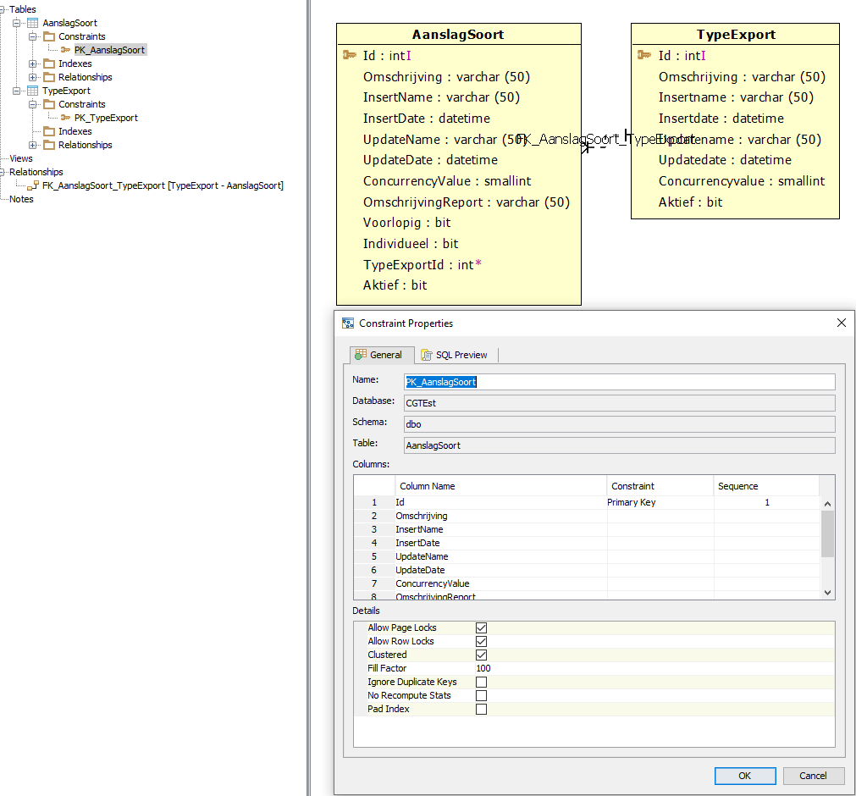

Import Again now import AanslagGroep en AanslagOpslag

Now check the properties of PK_AanslagSoort
