Complete steps followed with screen shots to reproduce problem.
To start, please see this Mongo Compass screen that shows the relative size of the collections. Notice the collection is 247 GB and the average document size is only 721 bytes.
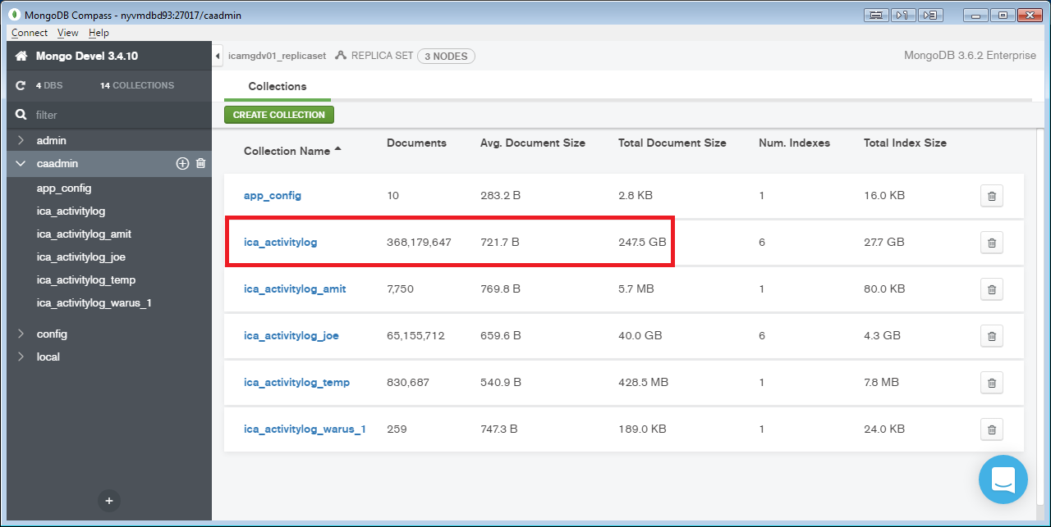
I closed ADS and started it again fresh. In ADS, choose collection, right click script to new window select (*), turn off show tree and pretty print json, enter 5 for max results:
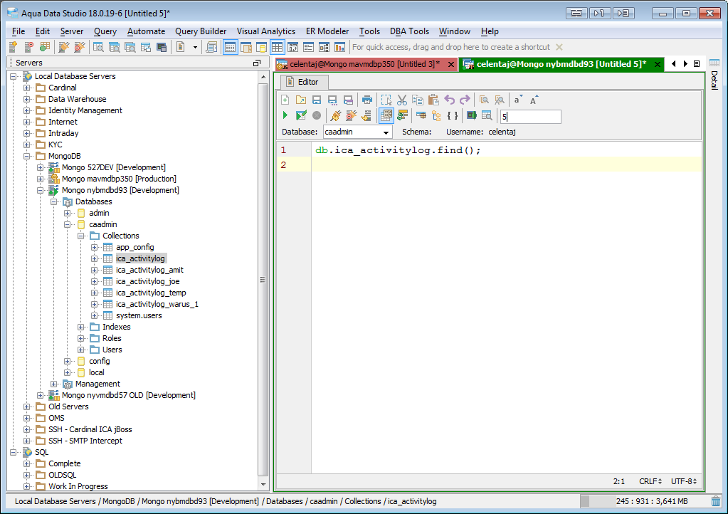
Here is the Query menu expanded:
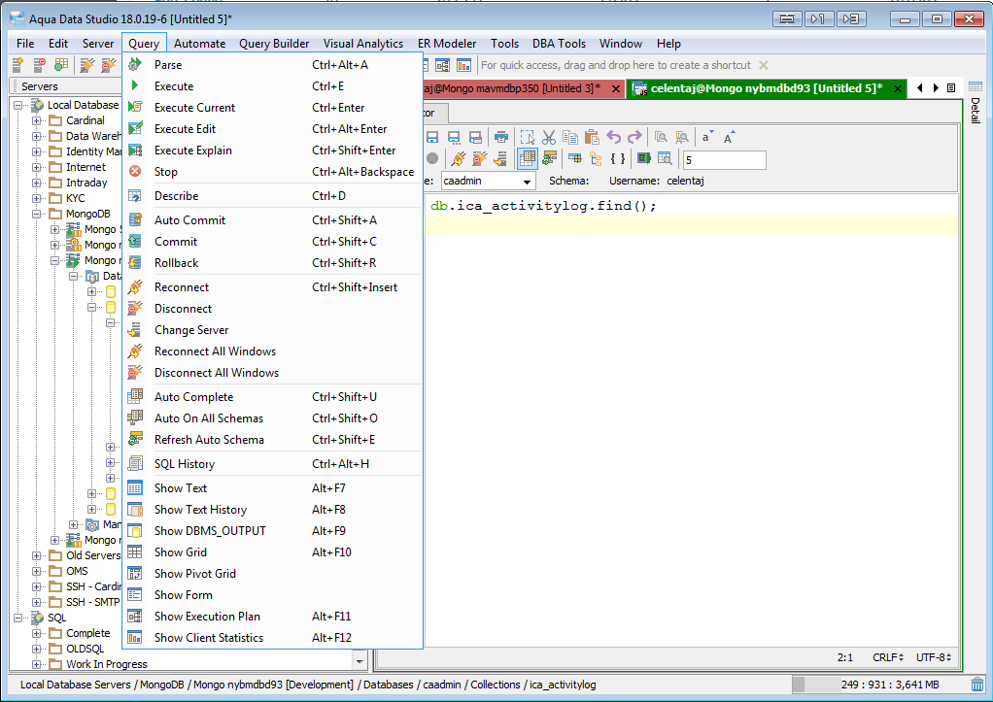
Notice the memory bar at the bottom. Hit Ctrl-E to execute the query. At 30 seconds I took another screenshot:
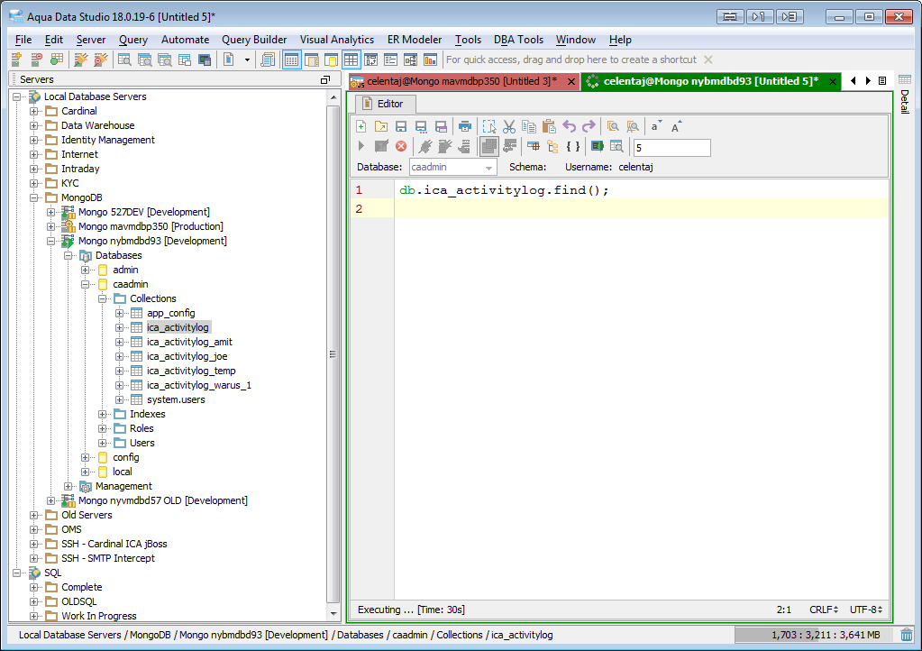
At 1 minute, I took another screen shot:
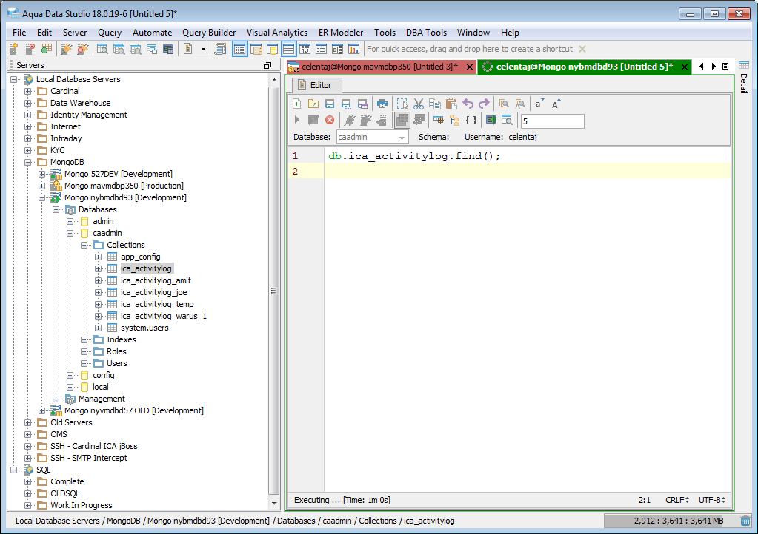
Ultimately, we go to not responding:
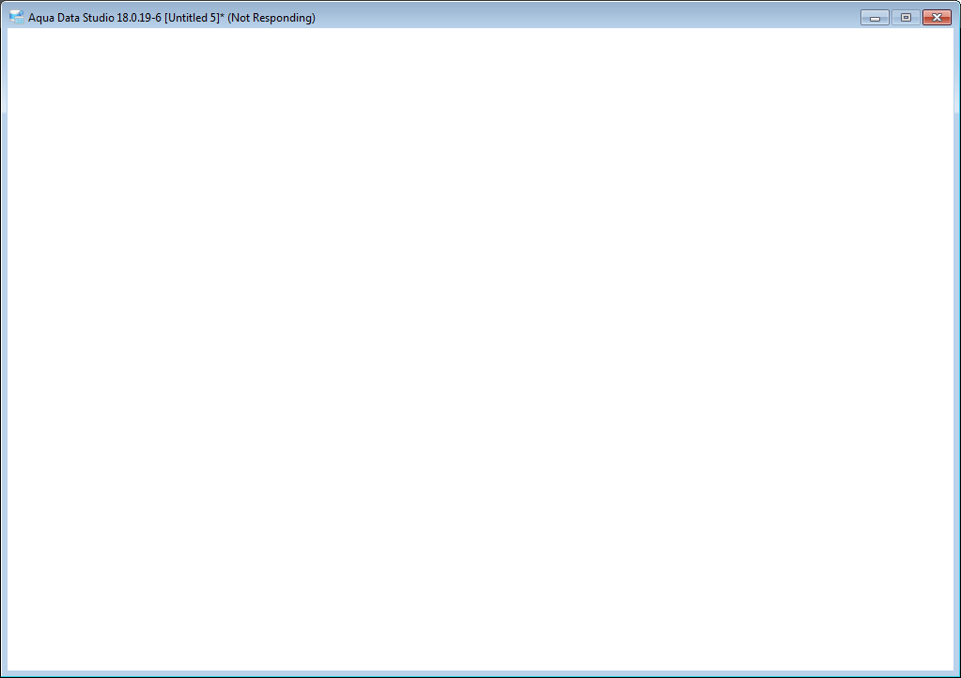
And finally:
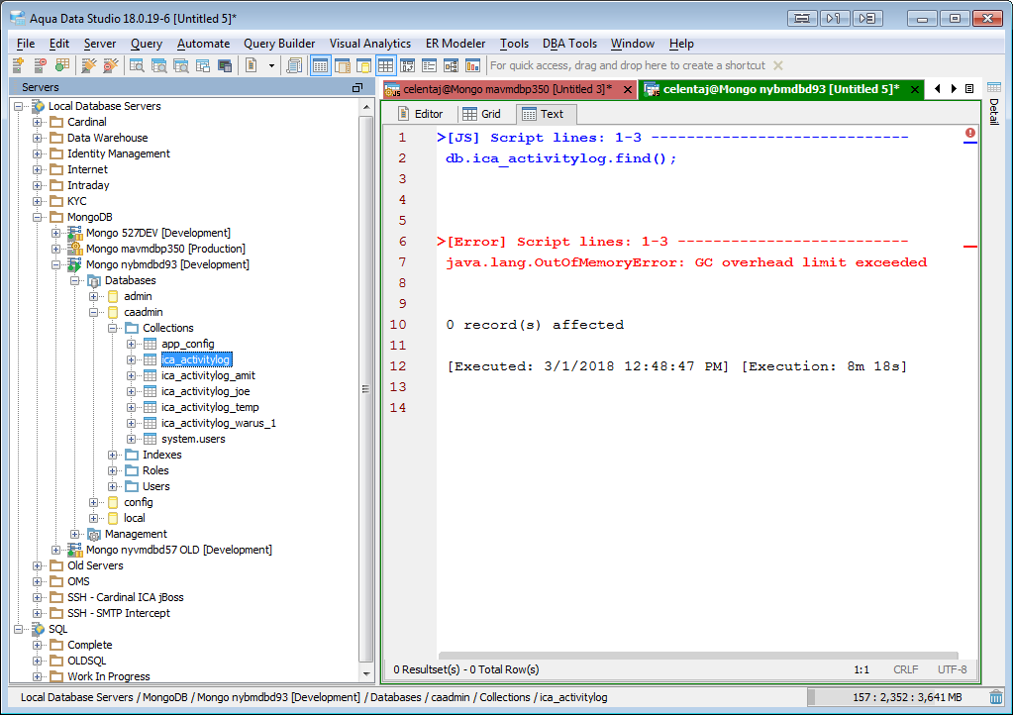
If I change the collection name to a small collection, everything executes fine:
