Here is the Results Compare with the Excel spreadsheet below after clicking on the “View As Spreadsheet” button. Notice the integerColumn indicates it was 1 in the first result set and 4 in the second result set. The spreadsheet shows the change on the charColumn, but not on the integerColumn and DateColumn.

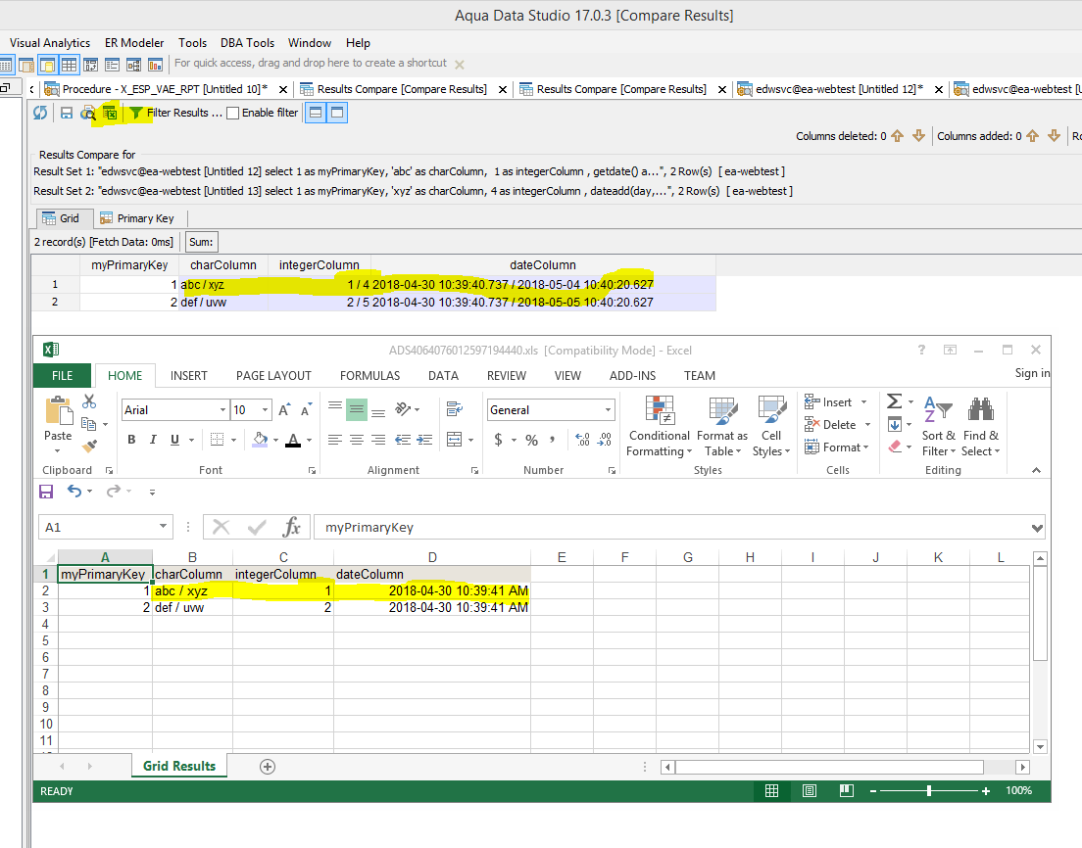

Below are the queries and results compare primary key setting that I used to create these screen shots:

